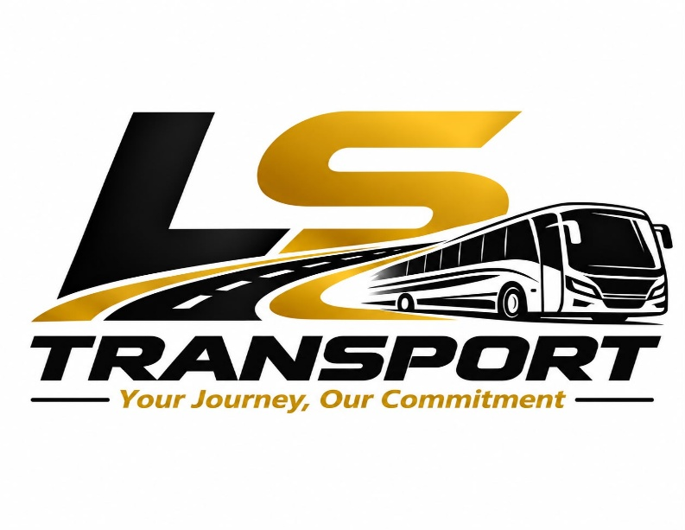

LS Transport – Website Write-Up (Senegal)
Home | Welcome to LS Transport Senegal
LS Transport is a modern, reliable, and customer-focused transport company operating across Senegal. We specialize in safe passenger mobility, efficient cargo movement, and dependable corporate transport solutions designed to support individuals, businesses, and institutions nationwide.
With a commitment to professionalism, national development, and service excellence, LS Transport ensures that every journey reflects our core promise:
Your Journey, Our Commitment.
About LS Transport
LS Transport is a Senegal-based transport service provider dedicated to delivering high-quality mobility and logistics solutions. Established with the mission to support Senegal’s growing economic landscape, we combine local expertise with modern transport standards to serve clients across Dakar, and beyond.
We operate with a strong focus on safety, punctuality, and customer satisfaction. Whether transporting people or goods, LS Transport stands as a trusted partner for reliable movement across the country.

Our Mission
To provide safe, efficient, and accessible transport solutions that connect communities, empower businesses, and contribute to Senegal’s economic growth.
Our Vision
To become one of Senegal’s leading transport companies—recognized for reliability, innovation, and exceptional customer service.
Our Slogan
Your Journey. Our Commitment.

Our Values
- Integrity: Honest, transparent, and ethical operations.
- Commitment: Dedicated to customer satisfaction and national development.
- Innovation: Modern solutions for evolving transport needs.
- Community: Supporting local employment and economic growth.

Our Services
LS Transport offers a wide range of transport solutions tailored to individuals, companies, and institutions:
1. Passenger Transport
- City-to-city travel
- Corporate staff transport
- Airport pick-up and drop-off
- Private hire for events, conferences, and tours
2. Cargo & Goods Transport
- Nationwide delivery of commercial goods
- Secure movement of equipment and materials
- Scheduled and on-demand freight services
3. Corporate & Government Transport Solutions
- Dedicated fleet for organizations
- Long-term transport contracts
- Customized mobility solutions for projects
4. Special Transport Services
- VIP transport
- Tourism and guided travel
- Humanitarian and NGO logistics support

KINDLY ADD NICE PICTURES OF BUSSES OR VEHICLES FOR EACH OF OUR SERVICES.

Why Choose LS Transport?
- Reliability: We deliver on time, every time.
- Safety First: Professionally trained drivers and well-maintained vehicles.
- Nationwide Coverage: Serving all major regions of Senegal.
- Professional Service: Courteous staff and transparent communication.
- Affordable Pricing: Competitive rates without compromising quality.
- Modern Fleet: Clean, comfortable, and efficient vehicles.

Contact Us
LS Transport – Senegal
- Phone:
- Email:
- Address: Dakar, Senegal
- Operating Hours: 7:00 AM – 9:00 PM (Daily)

Team
Abdoulie Lowe
Chief Executive Officer

Abdoulie Lowe is the Chief Executive Officer of LS Transport in Senegal, where he leads the company’s strategic direction, growth initiatives, and nationwide service delivery. With a strong background in multi-sector leadership across the United States, West Africa, and The Gambia, Abdoulie brings a blend of international experience and local insight that strengthens LS Transport’s position as a reliable mobility and logistics provider.
His professional journey includes leadership roles in Adult Family Home operations in Washington State, fire safety services through Sound Fire & Safety LLC, clean-energy and EV infrastructure development in The Gambia, and transport and logistics operations across Senegal. This diverse experience allows him to apply global standards to local transport needs, ensuring LS Transport delivers safe, efficient, and customer-focused services.
Abdoulie is recognized for his integrity, operational discipline, and commitment to service excellence. He is driven by a vision to modernize mobility across Senegal, expand access to dependable transport solutions, and support national economic development. Under his leadership, LS Transport continues to grow its fleet, enhance service quality, and build a reputation as one of Senegal’s trusted transport companies.

Haddy Saho
Chief Operating Officer

Haddy Saho is the Chief Operating Officer of LS Transport in Senegal, where she oversees daily operations, fleet management, staff coordination, and service quality across all transport services. With a background in nursing and extensive experience managing Adult Family Homes in Washington State, USA, Haddy brings a disciplined, detail-oriented, and people-centered approach to operational leadership.
Her career includes roles as a professional nurse, Adult Family Home administrator, and CEO of Bothell Serenity AFH Corp, as well as Group COO of LS Global Holdings. This multi-sector experience strengthens LS Transport’s operational systems, ensuring the company meets both local expectations and international standards.
Haddy is known for her precision, integrity, empathy, and commitment to service excellence. She focuses on building strong teams, maintaining high safety standards, and delivering reliable customer service. Under her leadership, LS Transport continues to expand its capacity, improve efficiency, and support Senegal’s growing mobility needs.

Nixon Kwaku Duah Junior
Chief strategy Officer

Nixon Kwaku Duah Jr serves as the Chief Strategy Officer of LS Transport in Senegal, where he leads the company’s long-term strategic planning, market positioning, and expansion initiatives. With a strong background in development management, corporate finance, and business growth across the United States, Senegal, and The Gambia, Nixon brings a forward-thinking and analytical approach to shaping LS Transport’s future.
As CSO, Nixon oversees strategic partnerships, competitive analysis, and organizational development, ensuring LS Transport remains aligned with national mobility needs and emerging market opportunities. His work strengthens the company’s ability to scale operations, diversify services, and maintain a strong presence within Senegal’s evolving transport and logistics sector.
Nixon’s professional experience spans multiple industries, including Adult Family Home operations in Washington State, fire safety services through Sound Fire & Safety LLC, and clean-energy and EV infrastructure development in The Gambia. This multi-sector exposure allows him to integrate global best practices into LS Transport’s strategic roadmap.
Known for his disciplined execution, strategic insight, and commitment to sustainable growth, Nixon plays a key role in driving LS Transport’s long-term vision. His leadership supports the company’s mission to deliver safe, reliable, and modern transport solutions across Senegal.

